

ARTIFICAL INTELLIGENCE LAB



|  |  |
| --- | --- |
| 2019-CS-102 2019-CS-105 2019-CS-113 | Aroj Fatima  Vaniza Riaz  Rimsha Zaib |

**Dataset Description**

**Regression dataset: (KNN(regression),linear regression)**

This dataset contain nutritional values of household commodities.This dataset was used in ‘stigler’ problems where the main goal is try to figure out how to minimize cost of food while getting enough nutrients. . Here calories is dependent variable and protein_g, calcium_g, iron_mg, vitamin_a_iu, vitamin_b2_mg, niacin_mg, vitamin_c_mg are independent variable. In linear regression ,there is one dependent and one independent variable .So here calories is dependent variable and vitamin_c_mg.

**Classification dataset:(logistic regression, KNN(Classification))**

The titanic dataset describe the survival status of individual passengers. The titanic data frame does not contain information from the crew, but it does contain actual ages of half of the passengers. The variables on our extracted dataset are Panssengerid, Age, Fare, Sex ,survived. Here survived is dependent variable and Panssengerid, Age, Fare and Sex are independent variable.

**Data Visualization**

**Classification:**

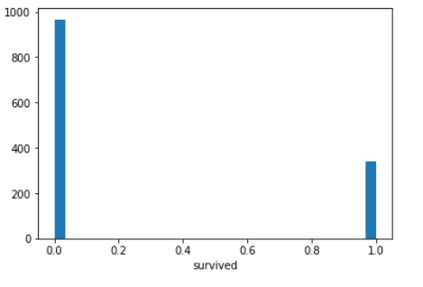

**Regression:**

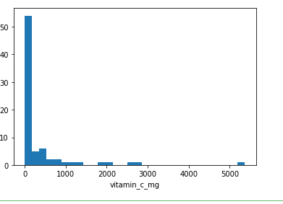

**Preprocessing**

* In the processing phase .I uploaded the database to Jupyter notebook.
* Afterwards I imported libraries which where Numpy, pandas, matplotlib, seaborn, sklearn
* count of missing values
* Data plot
* Identified dependent and independent variables.
* Split data into train test
* Import required model
* Fitting the required model
* model evaluation for train set(RMSE)
* model evaluation for test set(RMSE)
* Find Accuracy
* Predict unknown value

# Models

Linear Regression:

This model determines the relationship between the two variables by fitting a linear equation to observed data. It explains the relationship between the dependent and independent variable. Our dependent variable is calories and remaining are independent variables. Then we train our model using fit function and predict the values and calculate the root mean squared error (RMSE) .

Logistic Regression:

This model predicts the class based on different features. We use binary logistic regression in which it predicts the wheather the passengerid is survived or not survived. After giving different parameters it gives the result that in which class it will fall. Then we train the model and predict the values and calculate accuracy, MSE and R2.

KNN Model:

K-nearest neighbors (KNN) algorithm is a type of supervised ML algorithm that can be used for both classification as well as regression predictive problems. This algorithm uses ‘feature similarity’ to predict the values of new data points which further means that the new data point will be assigned a value based on how closely it matches the points in the training set.

MLP Model:

ANN Model:

The artificial neural network is used to predict the outcome of the set of inputs. An artificial neural network is a machine learning algorithm based on the model of human neurons. An artificial neural network is an information processing technique. It works like the human brain processes information. In general, neural networks are trained to as classifier to make classifications. But, in supervised machine learning, we usually need to make regression or make predictions, such as predict tomorrow's stock index or temperature.

Results

Logistic Regression:

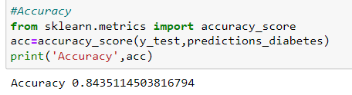

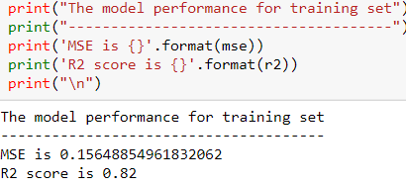

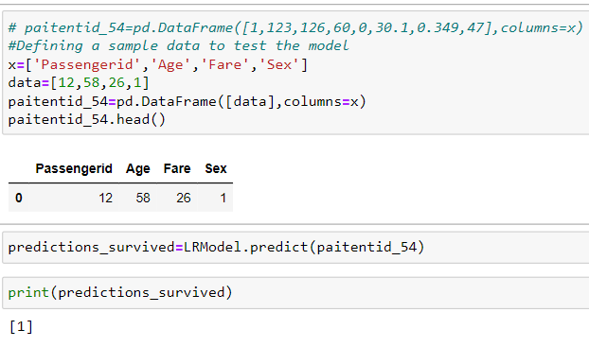

Linear Regression:

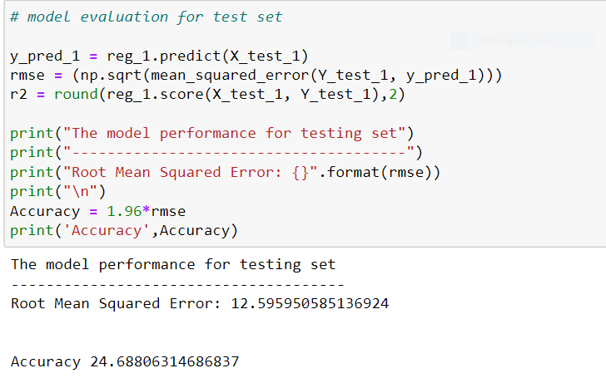

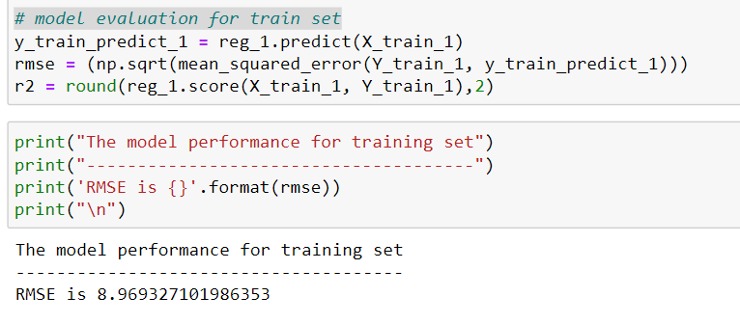

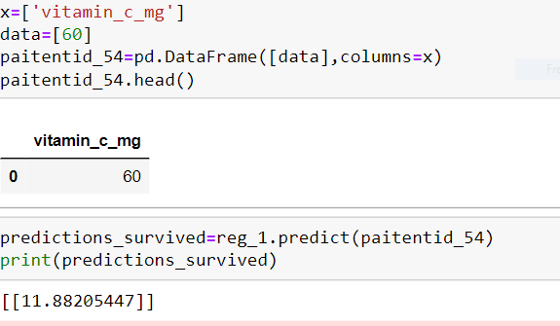

KNN classification:

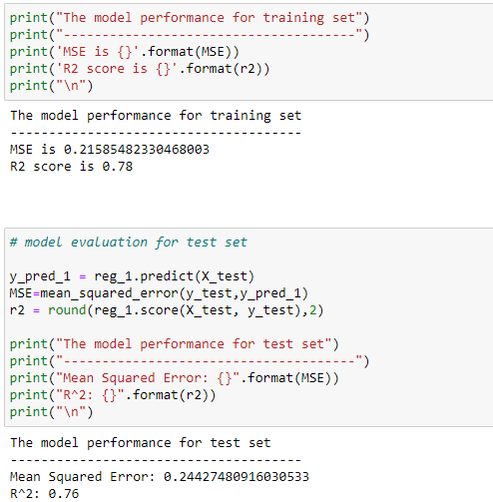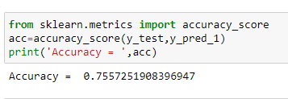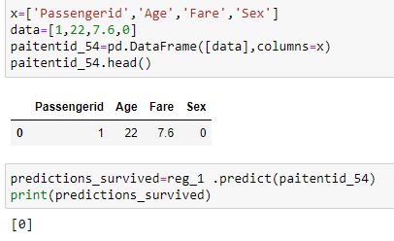

KNN regressor:

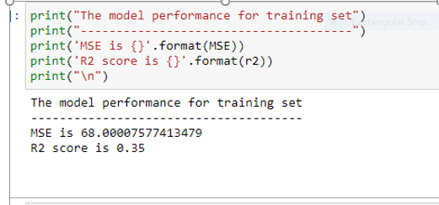

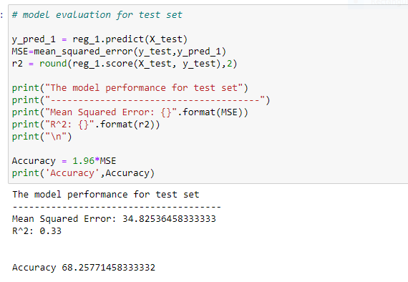

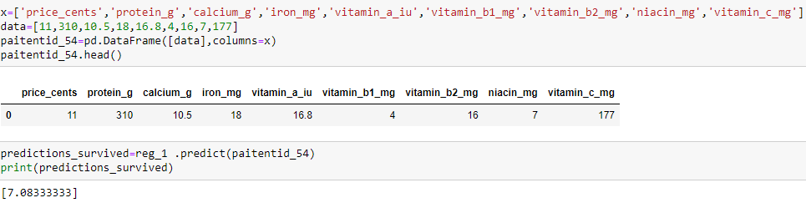

ANN for classification:

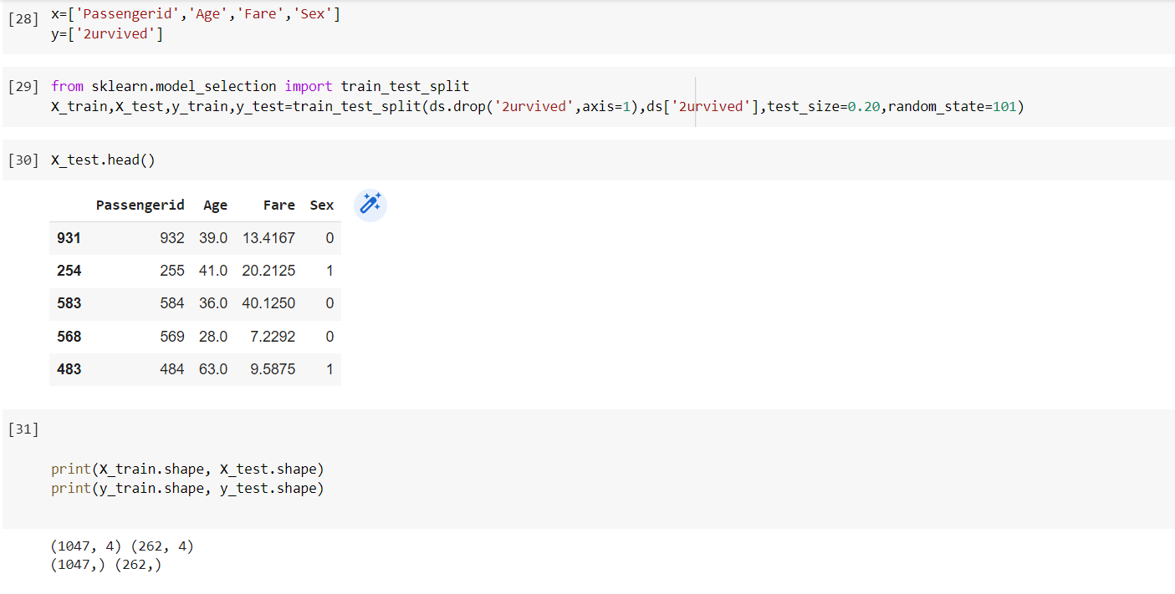

We have used three layers .The first and second layer is ‘relu’ and third layer is ‘sigmoid’.

